# Wind turbine analysis task using QBlade

In this task you will perform a BEM calculation of a small HAWT and compare to the experimental results obtained in the Wind Tunnel at NTNU. The guide below is to help you through this task, please see further guidelines on how to use the QBlade software in the manuals in the documentation folder of your download.

## Getting started

1. Download experimental data in the Lab directory from:

<http://home.hib.no/ansatte/gste/ftp/UiB_energi/>

1. Download the software QBlade: [www.q-blade.org](http://www.q-blade.org)
2. Run the executable file in the folder where you downloaded QBlade to start the software.

## Airfoil calculations

1. Go to the *Airfoil Design* module and then choose from the top menu *Foil* -> *Import Foil*.
2. Import the file you have downloaded, make sure it gets saved as .dat: S826.dat. (Not S826.txt.dat)
3. Go to the *XFOIL Direct Analysis* menu and to the right click on *New Polar.* Set the Reynolds number to *1e5* corresponding to the Reynolds number at the tip of the rotor blade at a design TSR of 6 [1]. The *Ncrit* should be set to 6 to better simulate the turbulence level in the experimental wind tunnel facility. Press *OK*.
4. Below the *New Polar* button, chose *Start value* -7 deg and *End value* 15 deg. This is for the angle of attack (AoA, Alpha) sweep for retrieving the airfoil force/moment coefficients. Leave the increment step ∆ at 0.5 deg. Press *Analyze*. You will see the graphs with results for the airfoil coefficients with respect to the angles of attack chosen.
5. To simulate a wind turbine, the AoA range of the polar needs to be extrapolated 360 degrees, this is done in the *Polar Extrapolation to 360* module. Press the *Extrapolate* button and you will see that the software has tuned the 360 polar to the initial data. You can try to fintune the A and B values if you wish. Press *Save*. See video (older version of qblade) for better understanding here:

<https://www.youtube.com/watch?v=LQoenvjN9g4>

The airfoil calculations are finished.

## Blade simulations

1. Go to the *HAWT Rotorblade Design* menu. In the top toolbar choose *Blade/Rotor* and *Import Blade Geometry in QBlade, Aerodyn or WT_Perf* format Open the file called NTNU_turbine.txt. Chose the calculated airfoil data in the **Foil** column in the table that appears. Do this for every row in the table as shown in the figure below.

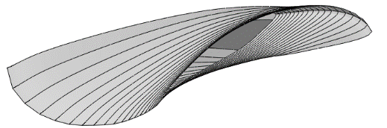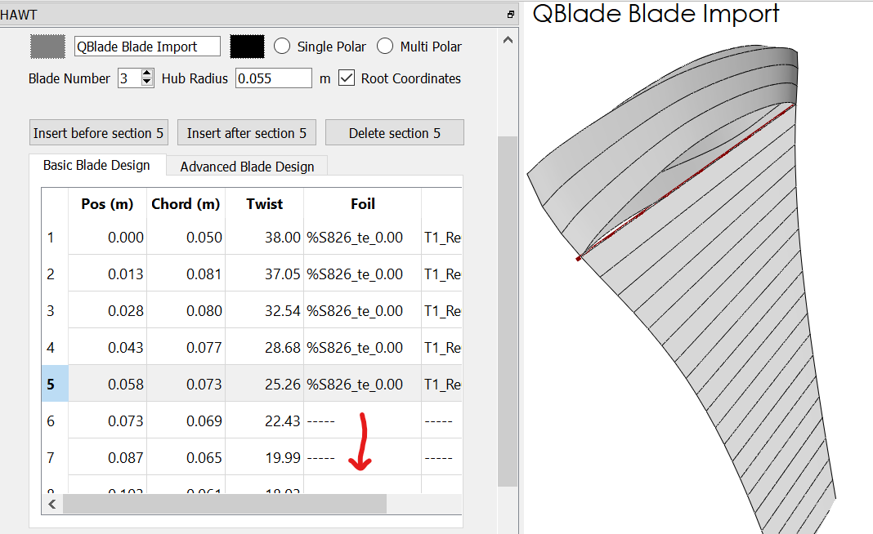

You can move the blade in 3D in the right window to see that it looks ok. Check that all spanwise positions have a foil shape.

Change the *Hub Radius* to 0.059m, this ensures a turbine rotor radius of *R* = 0.447 m according to the NTNU experiments in [1]. Press *Save*.

1. Go to the *Rotor BEM Simulation* menu. Press the *Define Simulation* button. Make sure that only the *Prandtl Tip Loss* and *Prandtl Root Loss* Corrections are checked. Press *Create*. Leave the *Analysis Settings* as default and press *Start Simulation*.

Now the simulation is done and you will see a Cp and Ct graph with respect to TSR.

## Comparison with experimental results

Right click on the Cp and Ct graph respectively and chose *Export Graph*. Save as *.txt* file. You can open the file in Notepad for example and see the TSR values in the first column and y-values (Cp or Ct) in the second column. Compare to the experimental data in the previously downloaded folder, NTNU_exp_data.txt where the first column contains the TSR values and the second and third columns contain the corresponding Cp and Ct values. Compare the results by plotting them in the same graph using your favourite engineering plotting tool.

Do your results resemble this?

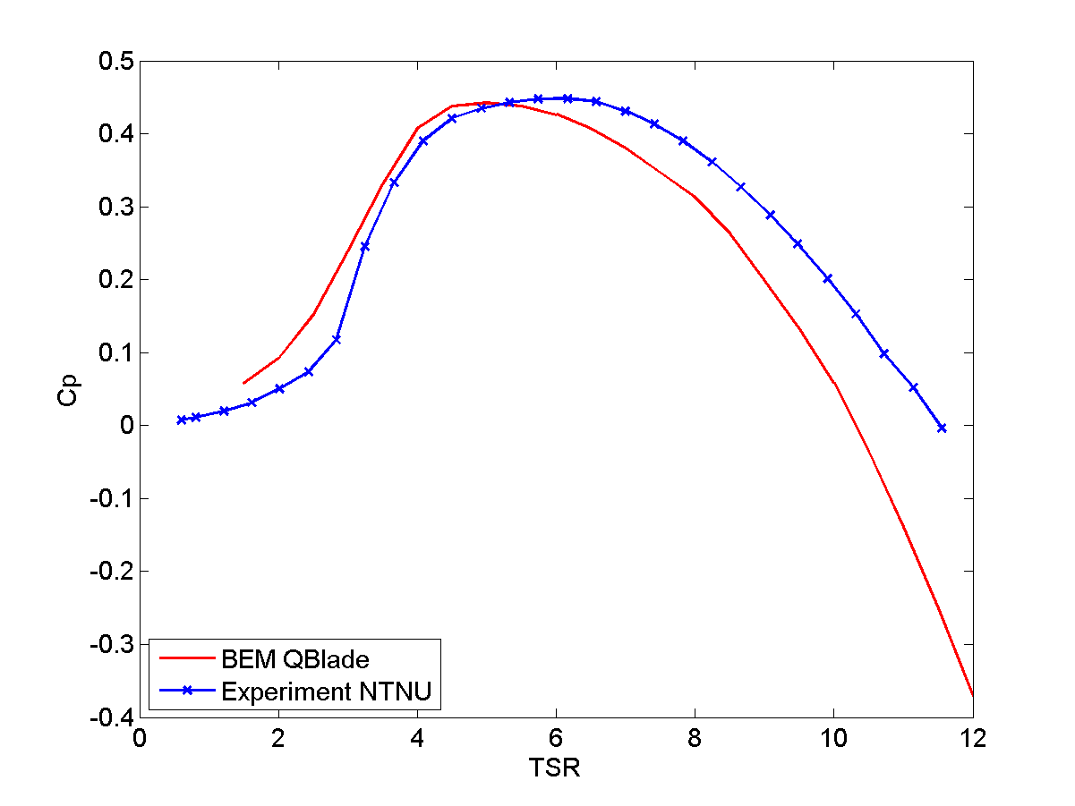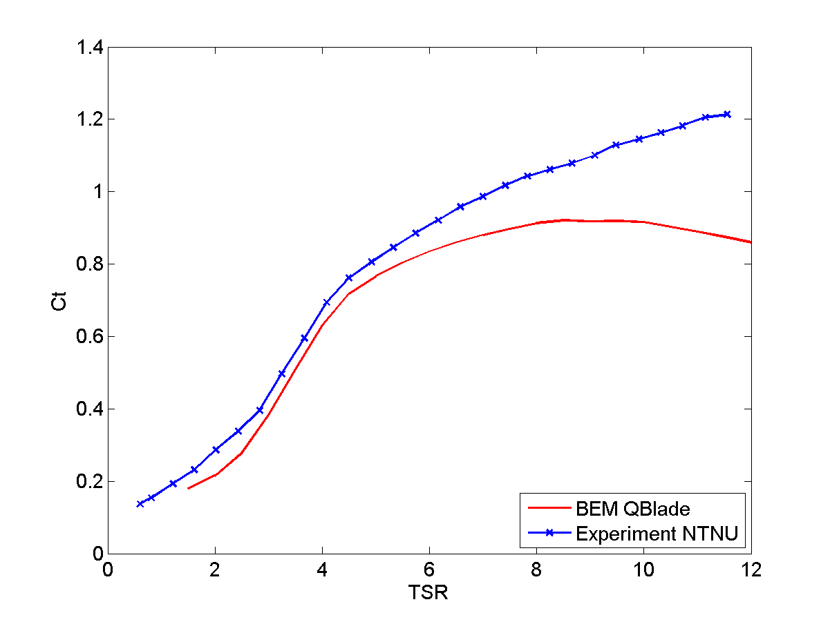

Are you impressed by the results? Why are the BEM results underpredicting Cp and Ct? If you compare to the BEM results shown in the lecture notes, a possible explanation is given.

## Change simulation settings

1. Press the *Define Simulation* button again. Uncheck the *Prandtl Tip Loss* and *Prandtl Root Loss* correction so that no corrections are checked. Press *Start Simulation* again. Compare to the previous simulation. How can you explain the difference, i.e. why does the first simulation give lower values on Cp and Ct for the operational TSR range?

Power generated by turbine

1. Note the TSR at maximum Cp on the first simulation with Prandtl loss corrections. Also note the maximum Cp value.
2. Use the optimum calculated TSR (lambda) to obtain the RPM for the turbine. The RPM can be found by the formula , given in [1]. You need to convert  [rad/s] to RPM [rev/min].
3. Calculate the available power in the wind,, in a cross section equal to the swept area *A* by the rotor [2]. Use a free-stream wind speed of 10m/s, which is the speed used in the NTNU wind tunnel experiment.
4. 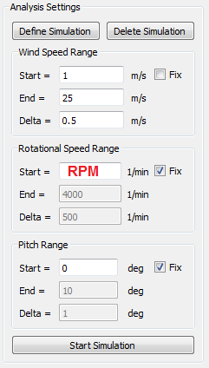Go to the *Multi Parameter BEM Simulation* menu. Press *Define Simulation*

and check the corrections for Prandtl Tip and Root Loss. Press *Create*.

1. Enter your calculated RPM in the *Analysis settings* where shown to the right.

Other settings as shown in the figure. Press *Start Simulation*.

1. A power versus wind speed curve is created. Read out the power at 10 m/s.

Compare this power to *Pavail*. Calculate the Cp of the turbine based on

these numbers. (Hint:  [2-3])

1. Reflect on the amount of energy produced by this small wind turbine. Give

an example of what can be powered by this energy. How big does a

wind turbine with the equivalent Cp need to be to produce 1MW?

# References

[1] P. Å. Krogstad, P. E. Eriksen, and J. A. Melheim. Blind test Workshop Calculations for a modell wind turbine. NTNU Department of Energy and Process Engineering, 30 March 2011.

[2] M. O. L. Hansen. *Aerodynamics of Wind Turbines*. 2nd edition, Earthscan, 2008.

[3] T. Hansen. Aerodynamics of Wind Turbines. Lecture Notes in Energy 210, UiB, Bergen, 2016.